|  |  |  |
| --- | --- | --- |
| JDBC | JPQL | HQL |
| Query is written based on table names and column names. | Based on Entity name and attribute names. | Based on Entity name and attribute names. |
| Query is already in executable format. | JPQ is translated into Database Query. | HQ is translated into Database Query. |
| Case-insensitive | Entity name and attribute names are case-sensitive but everything else is insensitive. | Entity name and attribute names are case-sensitive but everything else is insensitive. |
| Alias. | We can Identification Variable just like we assign alias to a Database Table to navigate object graph. |  |
| Query is Database dependent. | Independent | Independent. |
|  | Subset of HQL | Superset |
|  | Portable | Non-Portable. |

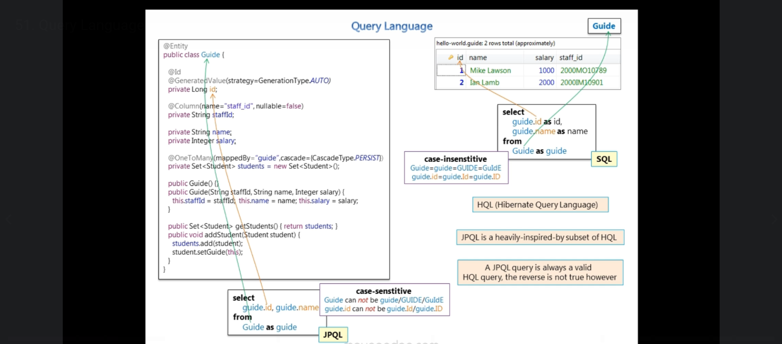

1. 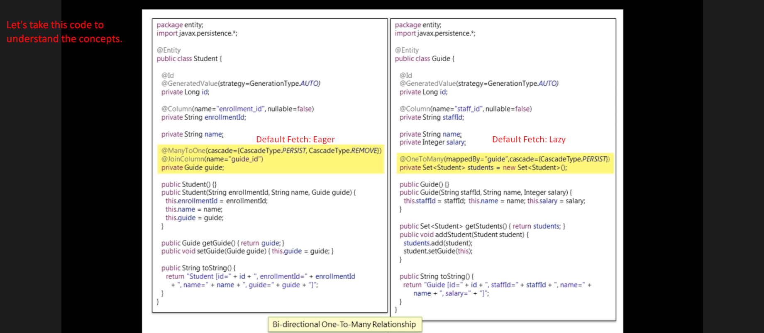
2. 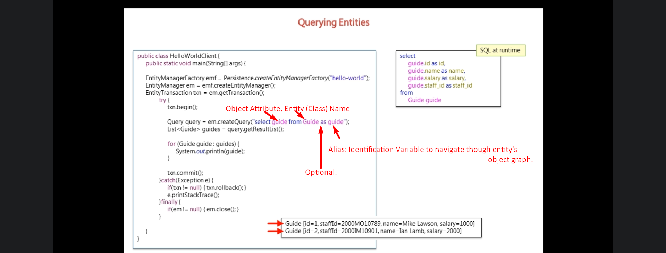
3. 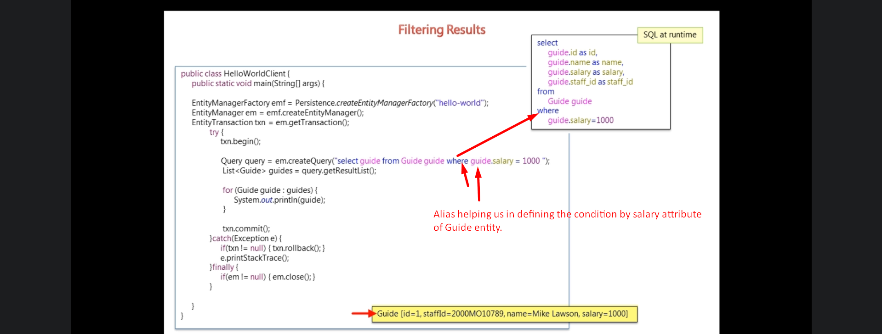
4. 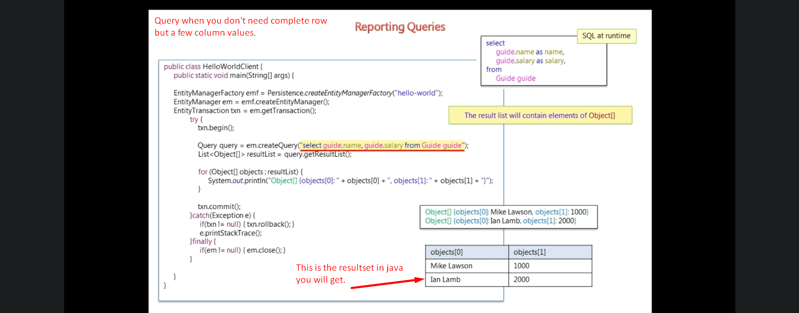
5. 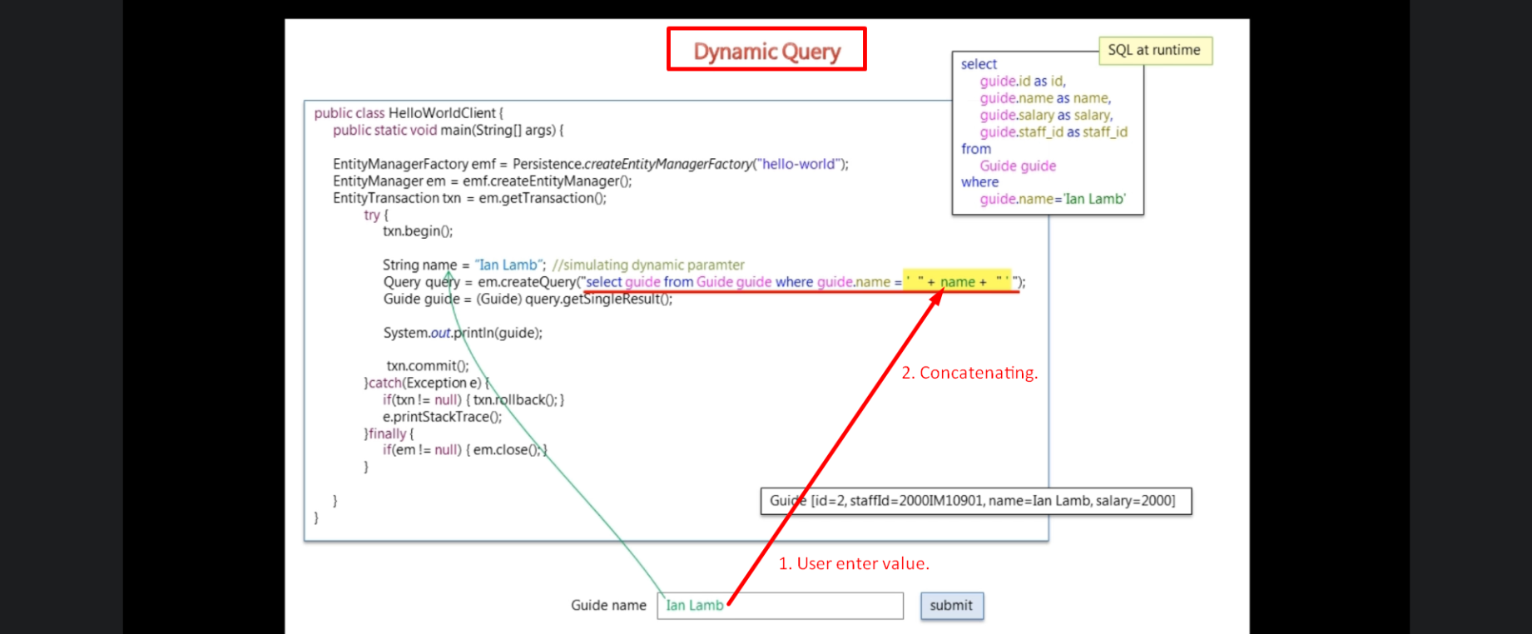 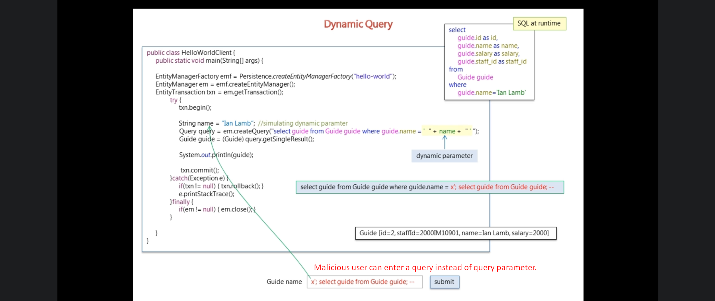
6. Solution:   
   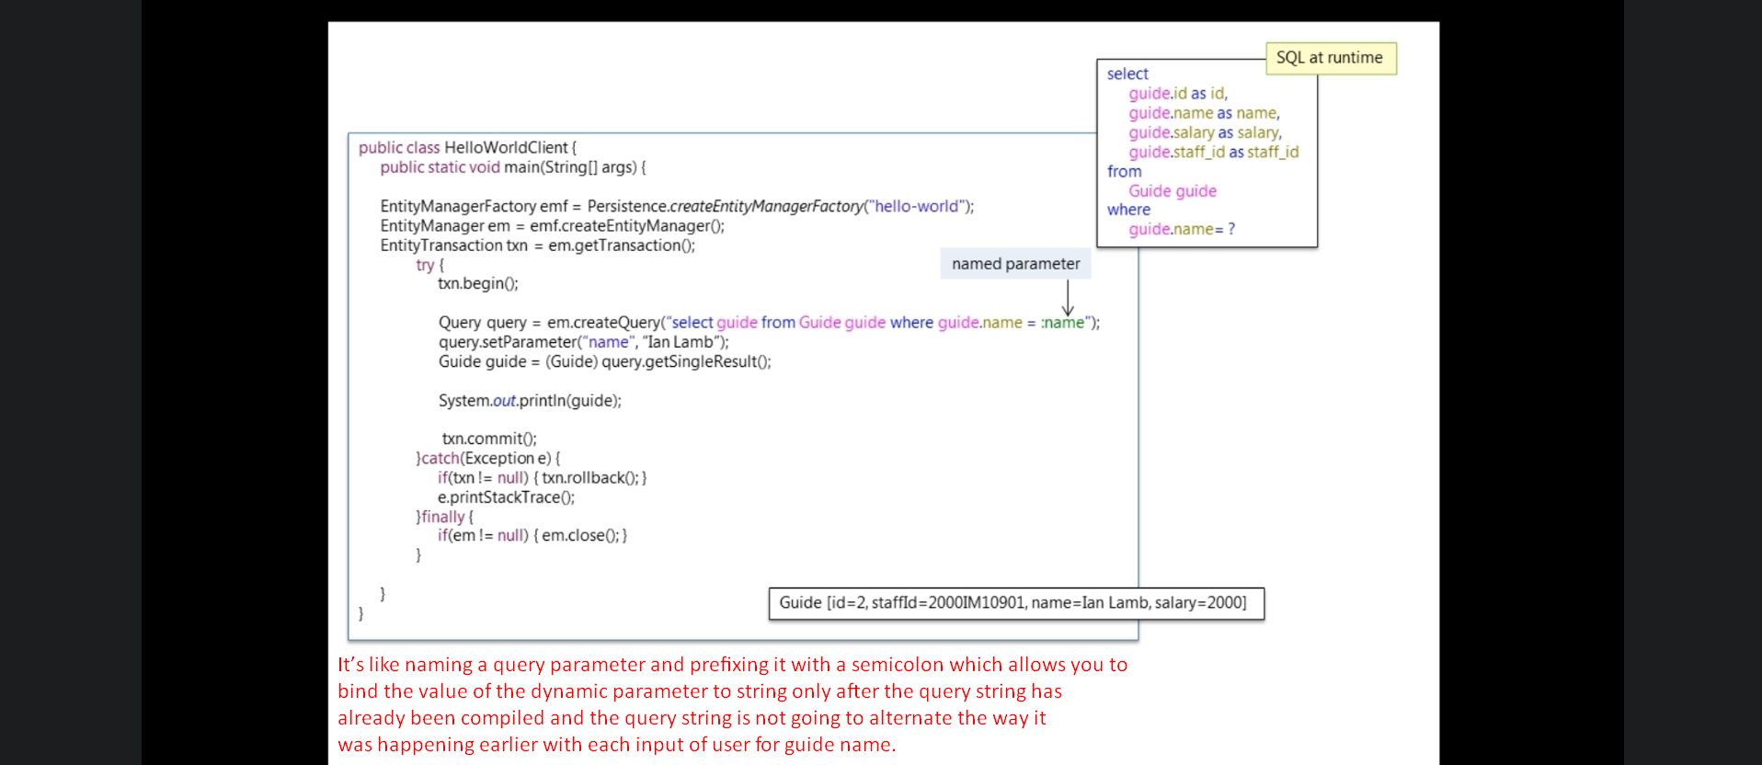
   1. **Named Parameter**:
      1. It’s like naming a query parameter and prefixing it with a semicolon which allows you to bind the value of the dynamic parameter to string only after the query string has already been compiled and the query string is not going to alternate the way it was happening earlier with each input of user for guide name.
7. **like keyword**: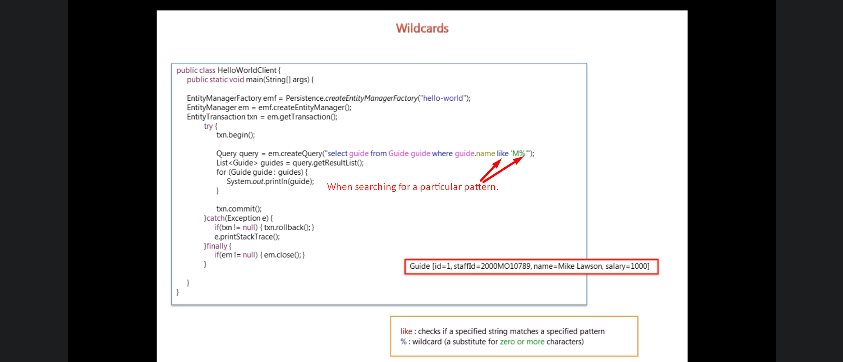
8. Native SQL Query:  
   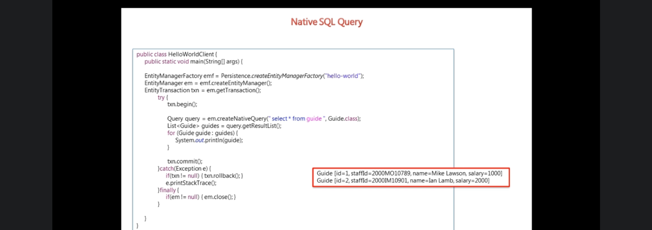
9. 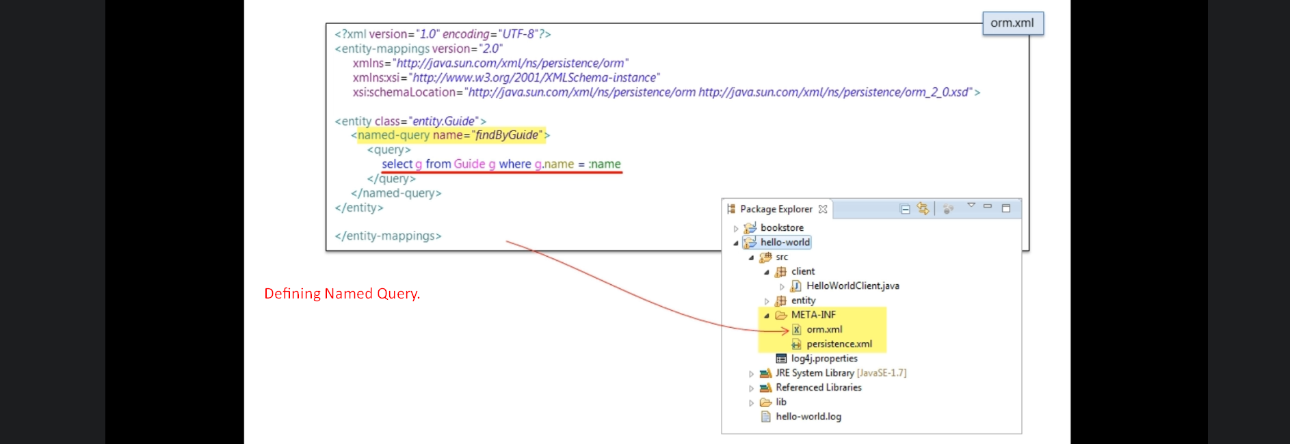
10. 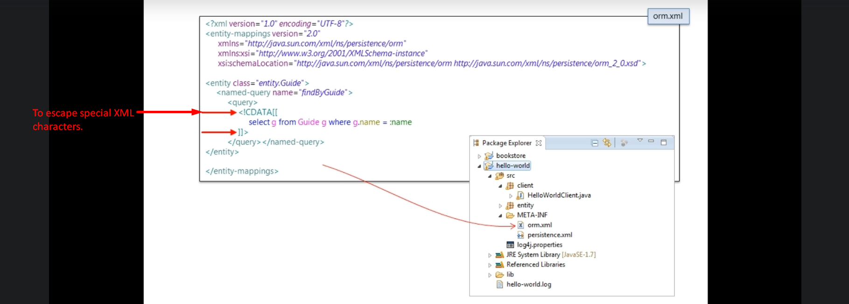
11. Named query is defined in the mapping document called orm.xml that is put inside META-INF folder for JPA.
    1. Hibernate automatically picks up this mapping metadata file automatically.
    2. The mapping meta-data defined this mapping xml file is in additional to annotation based mapping metadata defined in entity class (@Entity, @Table, @Id etc.)
12. 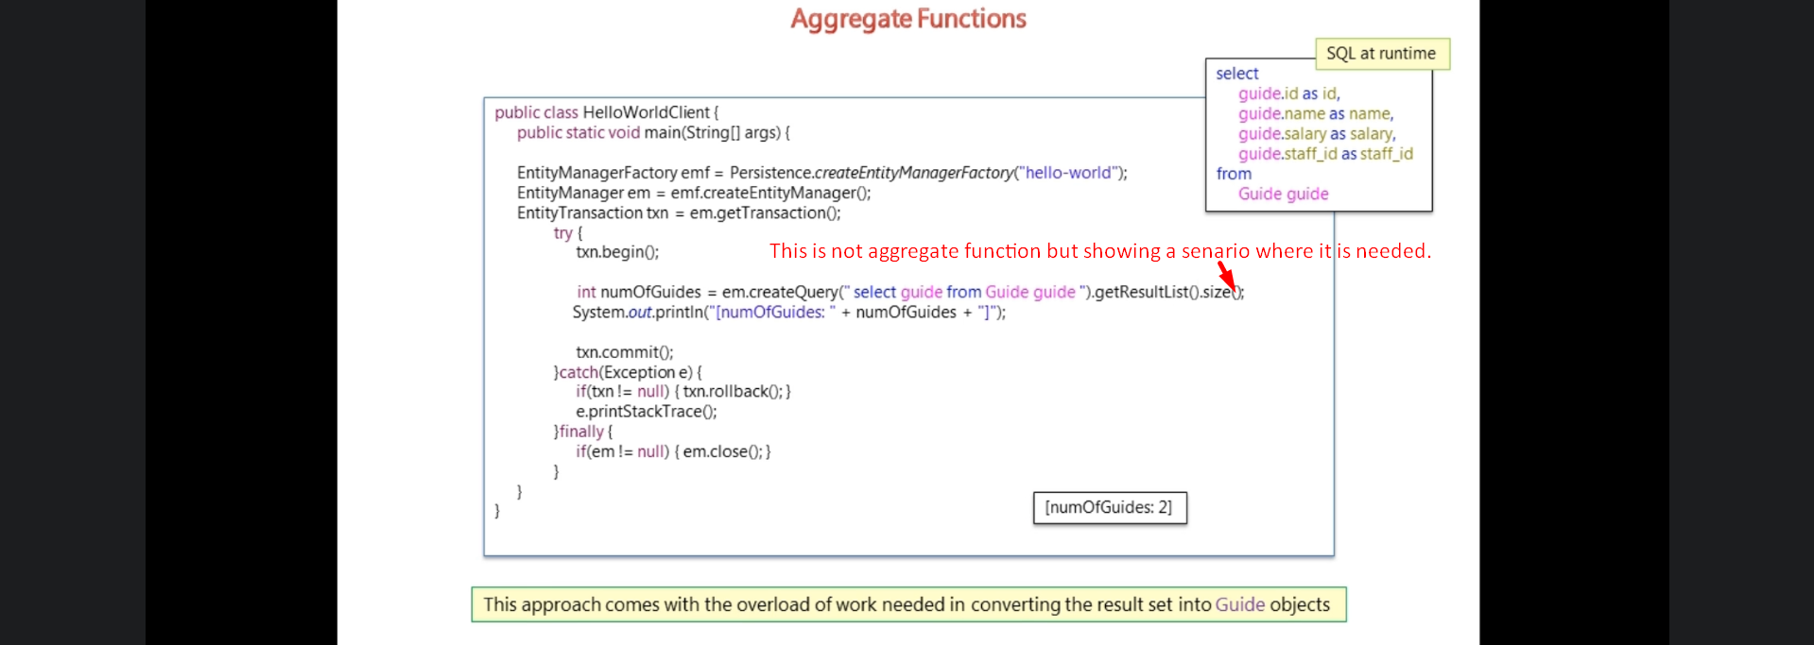
13. 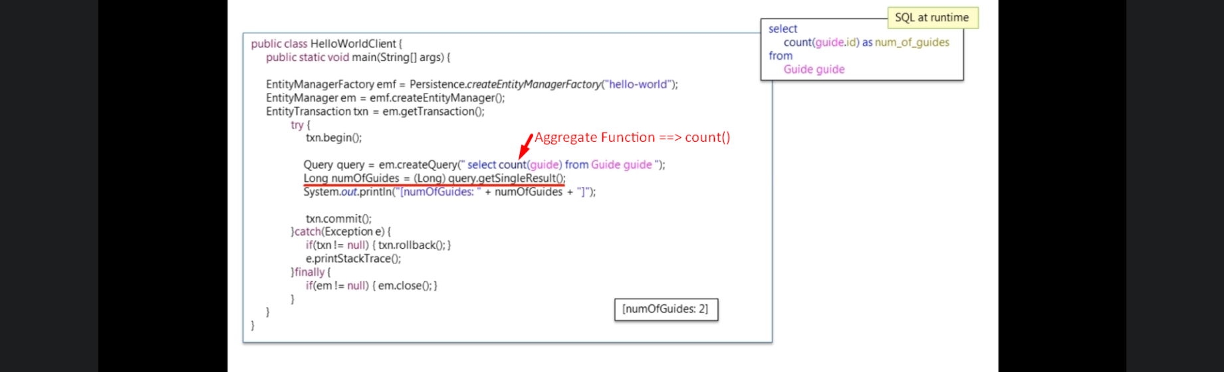
14. 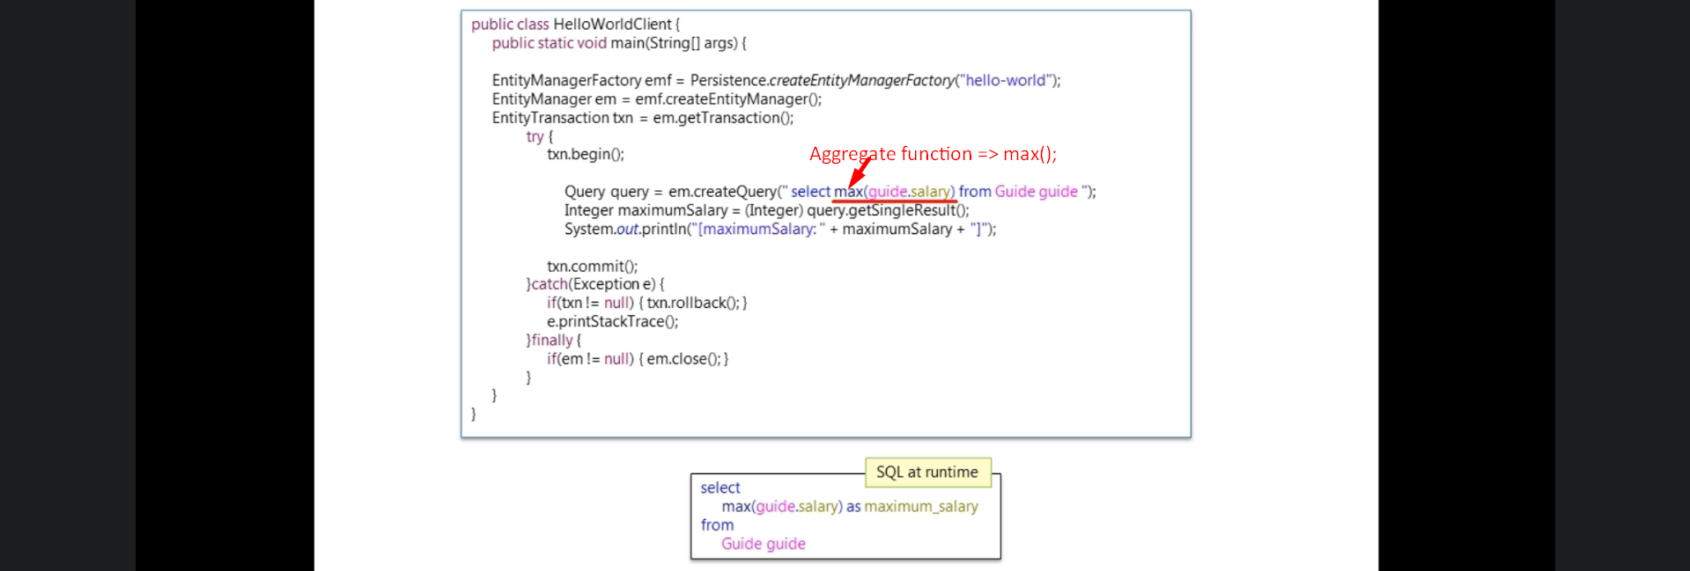
15. 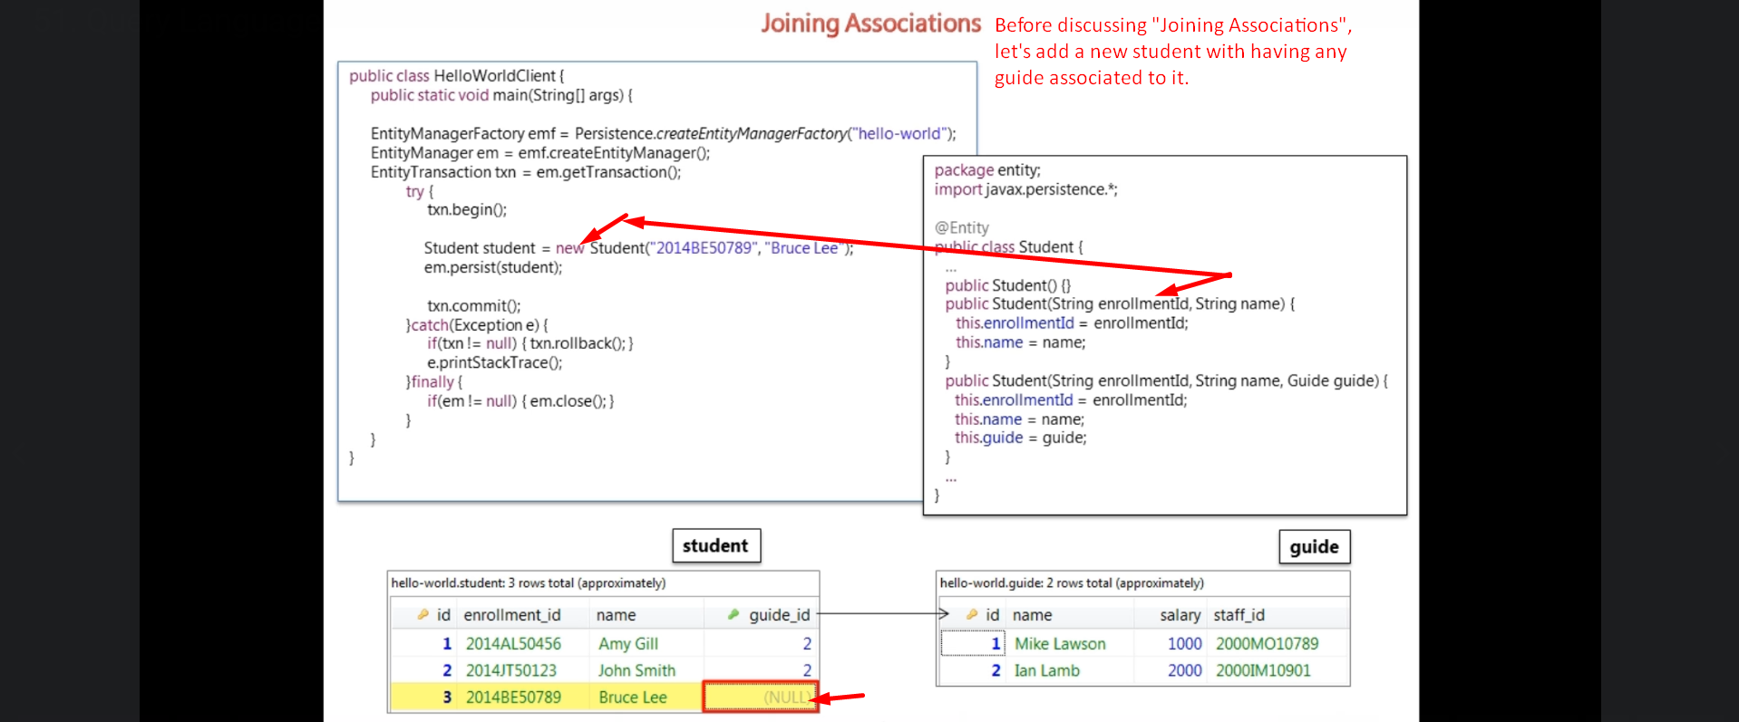
16. 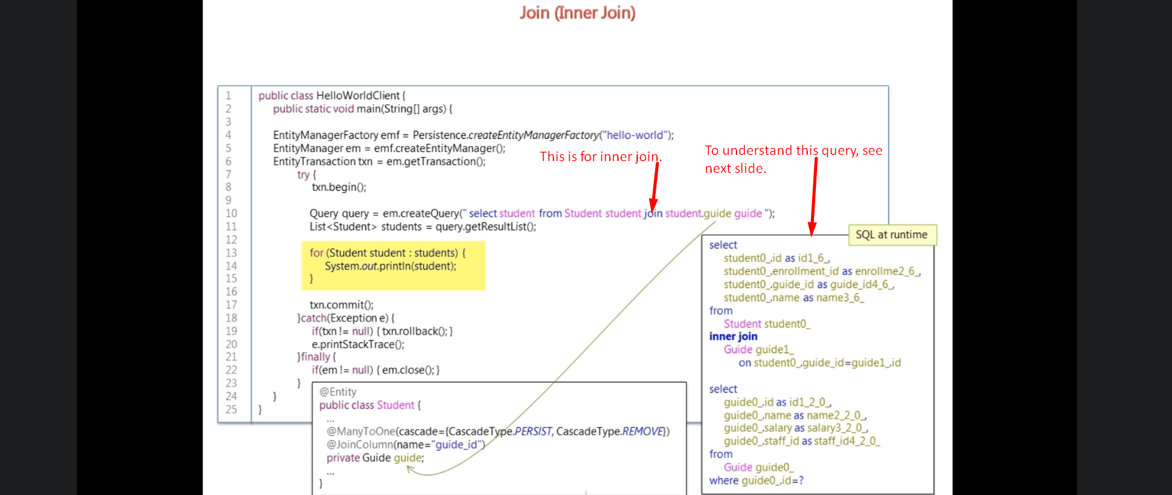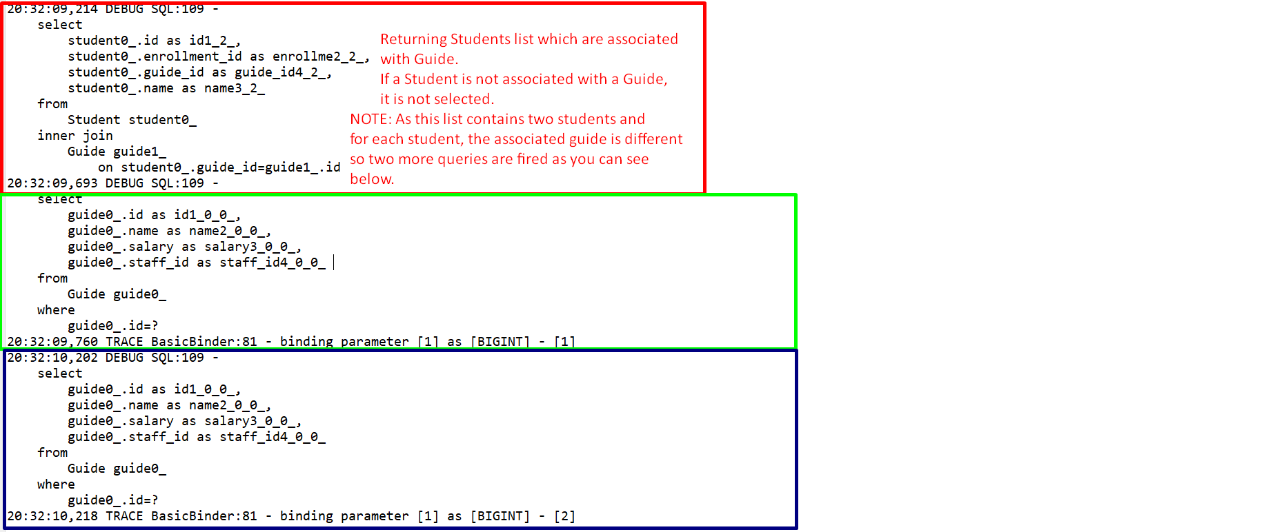
17. 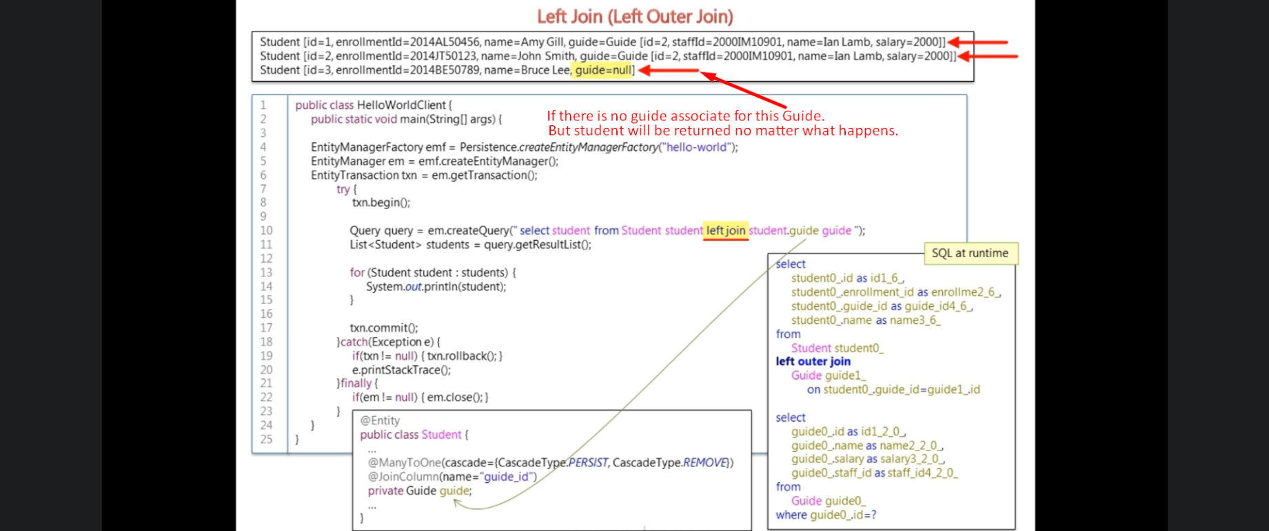
18. 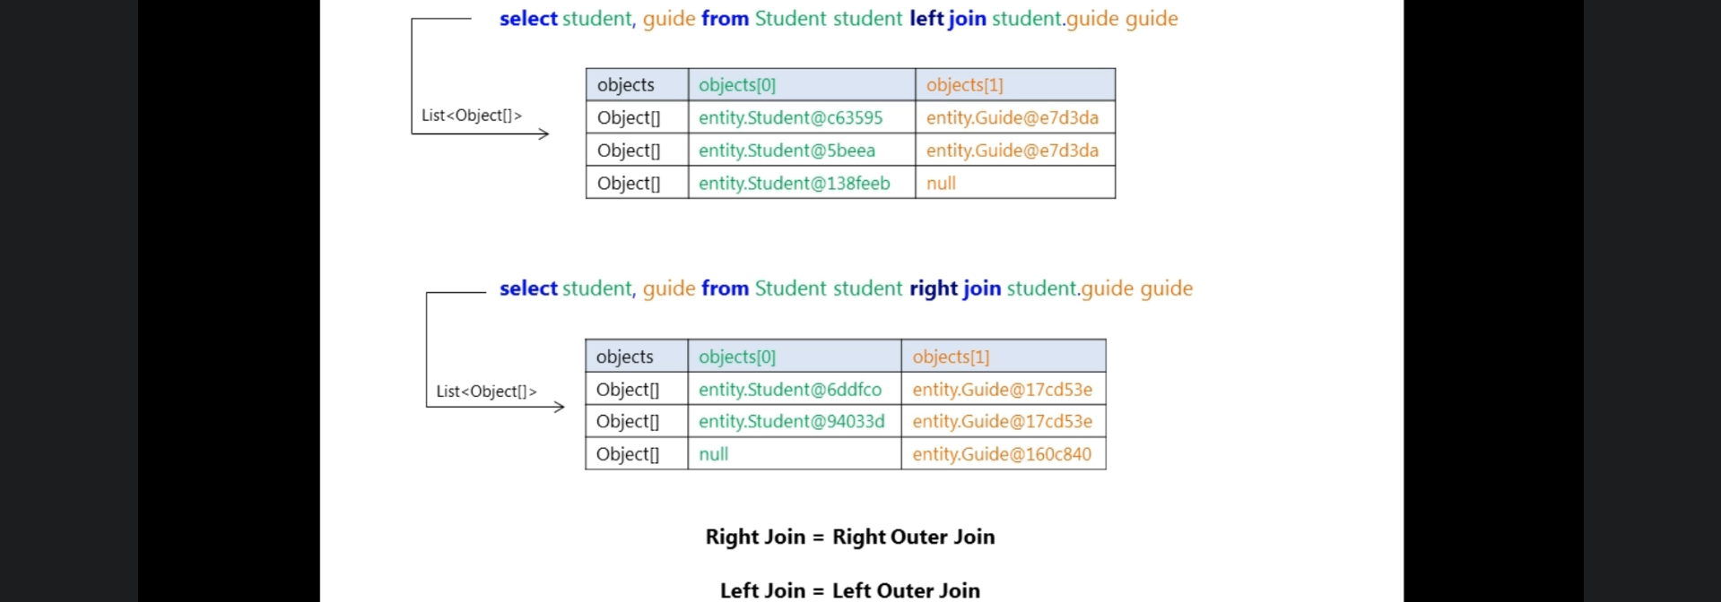
19.  
20. 